Gyro District IV Convention
Sept 23-25, 2022
Prince George, BC
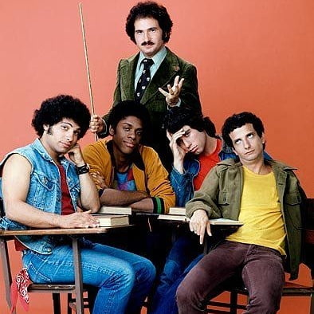
Welcome Back Gyros!

Who would have thought in March of 2020 that we would be where we are now? Not one of us!
So, what a tremendous opportunity to reunite in friendship at the 2022 Gyro District IV Convention in beautiful Prince George!
Sept 23 – 25, 2022 will be our chance to Welcome Back all our Gyro friends in weekend of frivolity and fun.
Friday, Sept 23 – Evening – Welcome reception and entertainment – bring your best stories and memories to share in this informal gathering of old friends
Saturday, Sept 24 – Morning – Business meeting for Club Presidents
-- Ladies event – Hosted by District IV and PG Gyro
Mimosas and Personal shopping (pls indicate if you will attend) ______
Saturday, Sept 24 – Daytime – After the morning business session and lady’s events, the afternoon is full of activities including a pub crawl, wine tasting, golf, a light hike or just relaxing in the splendour of BC’s northern capital. There may be additional charges for these events and they will be communicated at registration.
Saturday, Sept 24 - Evening – Installation of PG President Darren Masse and District Governor Marc Dumais, an evening of dinner and dancing and the chance to further connect with your favourite Gyro friends.
Sunday, Sept 25 – Morning – A hearty moosemilk breakfast will give us a chance to say fond farewells and adieu until our next Gyro gathering.

Details:
Event Venue: Prestige Treasure Cove Resort
2005 Hwy 97 S
Prince George, BC V2N 7A3
PrinceGeorge@PrestigeHotels.ca
Phone: 250.614.9111

Room Rates: $99/ night Group ID: 1493
https://www.prestigehotelsandresorts.com/locations/prince-george/overview/

Registration: $220 / couple - $110 single
Register with Joanne Slaney by Sept 21, 2021
jojoslaney@gmail.com
(250) 613-5266 – phone or text

Questions? For questions or further information please contact Joanne as above or
President Paul Williams – pauliams28@gmail.com (250) 613-8456
Convention Chair -Mike Millard mikemillard9@gmail.com (250) 961-7030

Covid Notes: BC is currently without restrictions on gatherings of our size. Should factors beyond our control prevent the gathering, all registration fees will be fully refunded. We will be adhering to all Government recommended safety measures in place at the time of the event (which of course may change after you register).
In the spirit of friendship, we would dearly love to see all of you and we miss your company! But in these difficult times, safety trumps friendship, so we are asking that only those who are double dose vaccinated sign up for this event.

